EE163 System Design Analysis Lab 5

Tasks:

A) Product name / part number / manufacturer?

|  |  |  |
| --- | --- | --- |
| Product name | Part number | Manufacturer |
| LCD Projector (“conference series”) | XG-V10XE | SHARP |

B) Function(s) of the product?

1.Take an image input and project the image onto a surface.

2.Take an audio input and amplify it and project the sound.

3.Provide a wireless method of changing slides/optical or audio output.

4.Tell the user when there is a fault.

C) How does the product achieve this/these function(s)?

|  |  |
| --- | --- |
| Function: | Achieved by: |
| 1 | Allowing multiple visual input choices for the user to send the projector data such as S-Video,DVI and VGA inputs allowing the user to switch between them as needed. The amplified image is given by using 2 bright white bulbs to boost the visual output. |
| 2 | The projector also has many old style audio L/R inputs for each visual input so the sound for each projected video can be swapped between as needed. These go to 2 8 ohm 3W speakers giving 39dB. |
| 3 | There are 2 remote control sensors, one on the back one on the front so that no matter which direction you use the remote from it should get a signal. The remote allows the user to do all projector functions and is the main method of control equal with the one built into the case. |
| 4 | There are 4 LED’s on the front of the projector to show when there is a temperature warning, or when each of the 2 bulbs need replacing and finally a power light so that it is known if the projector is getting power. |

D) Devise the method(s) by which the product was assembled.

**Casing**

The plastic casing appears to have been made by injection moulding 7 separate parts(top, bottom,left and right covers, handle,ports cover,filter cover) which have been tightly sealed together using screws with a hinge for the filter cover.

**PCB**

On all PCB’s in the device there is one side with both SMD and through-hole(top) and one with only SMD(bottom).As components are on both sides a solder bath cannot be used instead the following process as followed which is a type of re-flow soldering:[1]

First of all the blank PCB has solder paste fed onto the bottom pads probably using a stencil to save time and money, either a person or much more likely a machine will place the smd components on this PCB, the entire PCB is then heated attaching the parts through the force of gravity.

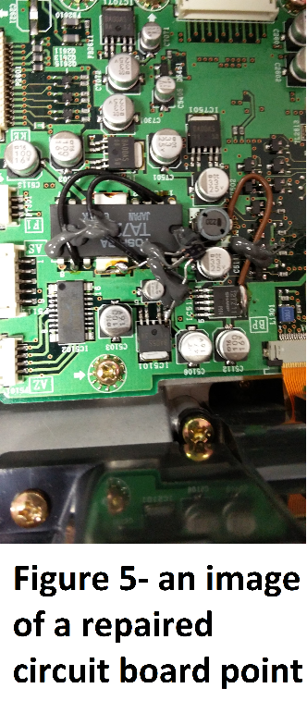Next the process is re-done with the SMD components on the top of the board, as smd component are light and solders surface tension is very high the components on the bottom fall off, if there were any heavy SMD components they would be glued or held in using a solder shield.

The through hole components are then put into the circuit board and another type of stencil (solder shield) is used to hold in the SMD components as the through hole components are wave soldered. The smd components cannot be held in through surface tension in a wave soldering machine as the solder joint is in contact with the solder bath so the surface tension is no longer on the joint.

**Other**

On the PCB at certain points there can be components found soldered on and wires connecting points to other points(fig 5) as the circuit board has many small holes in it I believe a bed of nails tester is used to test each PCB, and instead of the producers saying that this is faulty the bed of nails tester would say where the issue is and report this to the creator where the PCB can have small adjustments made to save the company the waste it would be to throw away the PCB

E) Describe the signal inputs and outputs from the product.

|  |  |
| --- | --- |
| Inputs | Outputs |
| Image/Video signal(s) | Corresponding projected image |
| Sound signal | Corresponding amplified sound wave |
| Infrared control signal | Change functionality of projector |
| Take internal components measurements | Tell the user when there’s an internal error |

F) Produce a Parts List for the product.

Due to the pure mass of the product it would take years to make a component list and there were so many sub systems working together only the main ones will be listed in this list:

|  |  |  |  |
| --- | --- | --- | --- |
| Plastic injection mould case | Filter | Failure indicator LED’s x4 | Infrared sensors x2 |
| 230V C14 input | Port expansion shield | S-Video input (4 pin mini din) x 3 | L/R audio pair inputs x7 |
| DVI input | 15-pin Mini D-sub input x2 | RS-232C input | RS-232C output |
| Wired remote input | DC 12V output | BNC input x11 | BNC output x3 |
| Mains on/off switch x2 | Onboard control buttons x20 | 8 ohm 3W Speakers x2 | Thermal fuses (A100 05N4160 2A01) x2 |
| Screws x Uncountable | Lenses x 18 | Dichroic optical coated lens x3 | Mirrors x6 |
| Rf shield x2 | Heatsinks x Uncountable | LCD screens x3 | Fans x 8 |
| Variable lens focus | Motors x3 | Unit PSU | Bulb PSU x2 |
| Bulb x2 (for functionality) | Trichroic Prism | 7 segment display | Low dropout regulator board (fan driver) |
| Plastic lens position holder | Video/audio input PCB | Lcd programming PCB x3 (one each for red, green and blue) | Speaker driver board |
| DVI input board | Control board (also the blue lcd board) |  |  |

G) Draw a system diagram for the product.

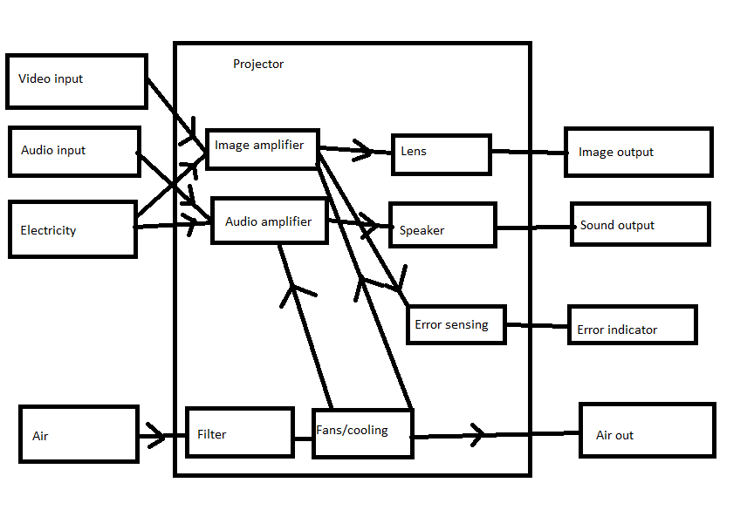

H) Suggest likely failure mechanisms for the product.

Methods of failure mechanism:

**Temperature warning indicator**- an indicator is given on the outside of the projector so that when the projector detects a temperature over a threshold the user is told so that they can react as needed.

**Power indicator**- Tells the user if the unit is getting power, this can be used to tell if there is an issue with the psu or if there is an issue with supplying the power so they don’t just throw away the entire projector.

**Thermal fuse**- Stops the projector in case of the unit getting above a threshold temperature to stop the unit becoming unrepairable damaged or starting a fire.

**Fuses**- on almost every circuit board there was a fuse on the input power so if it receives too much current or voltage it blows so that the entire unit doesn’t have to be replaced saving money and time.

I) Provide a description of the packaging and function of an individual electronic/electrical component from the product. Each student should choose a different component.

**Light manipulation channel**

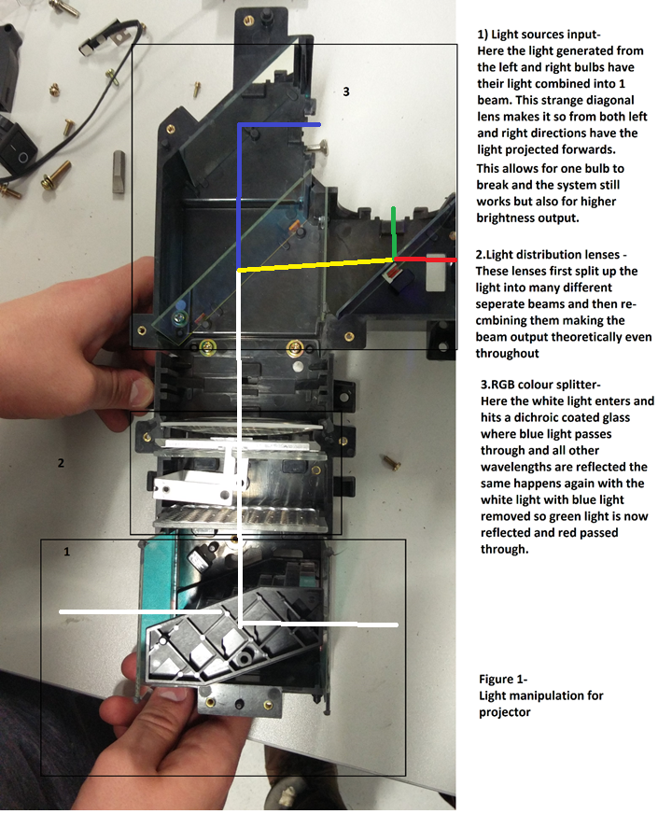

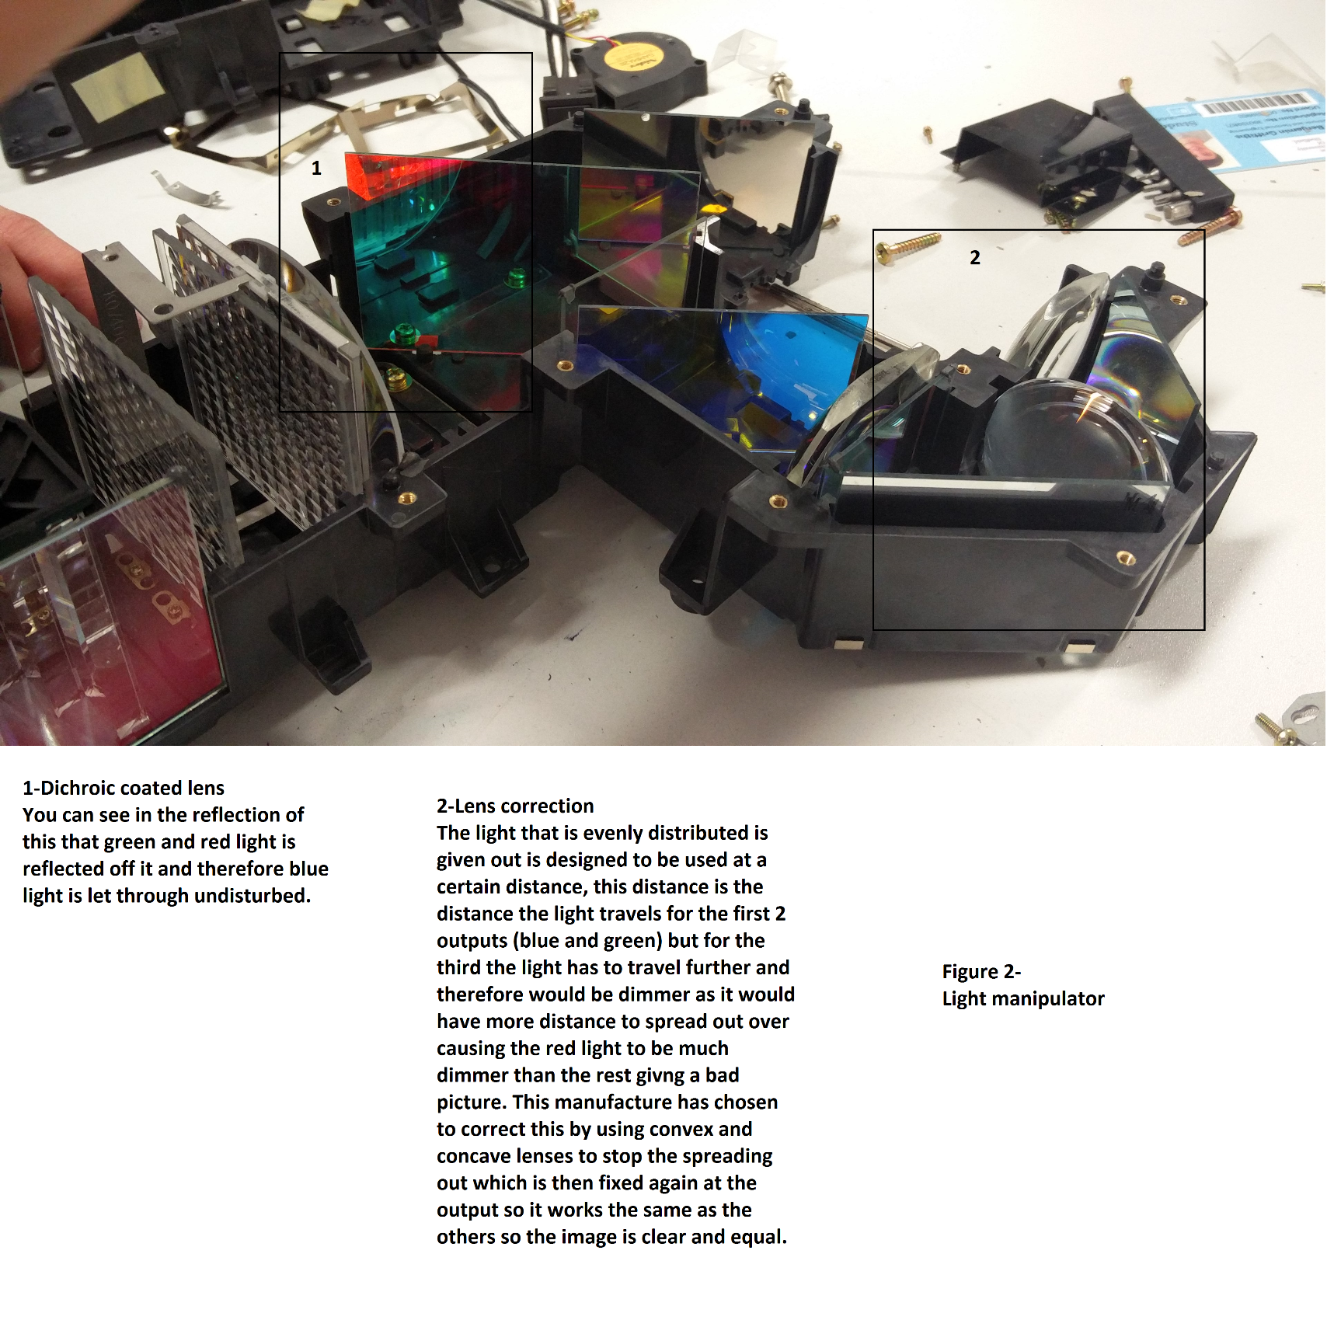

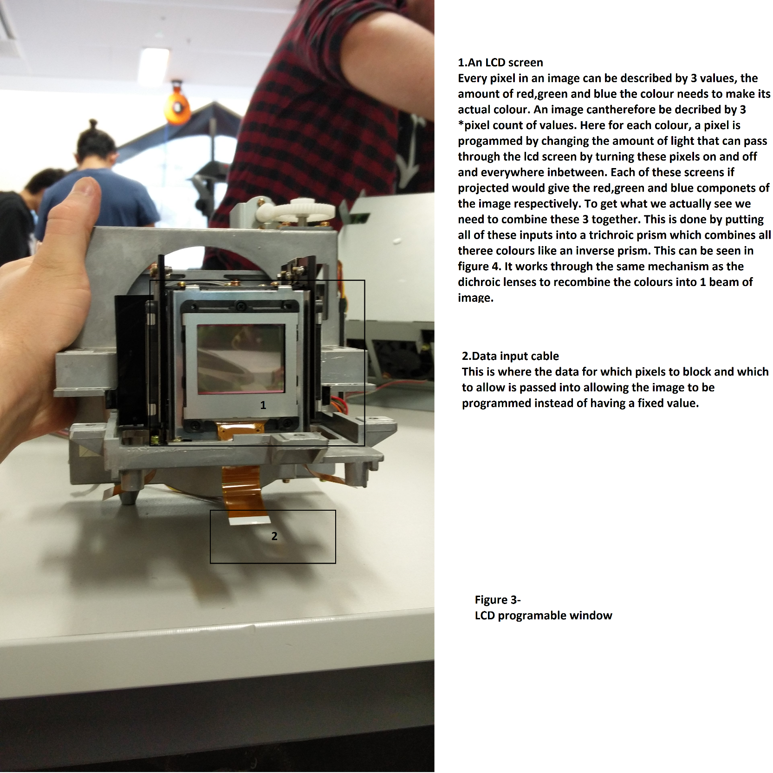

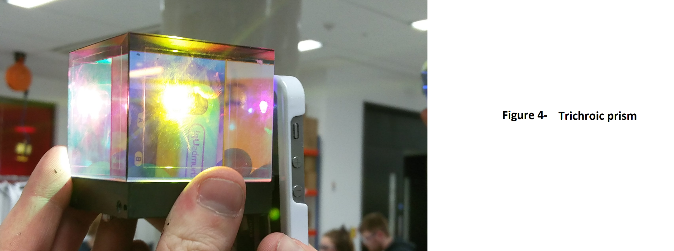

J) How does your item compare to a modern equivalent (performance, size, cost, power, etc.)?

|  |  |  |
| --- | --- | --- |
|  | Current | Modern |
| Performance | 4,700 ANSI lumens  1280x1024 resolution | 2500 ANSI Lumens  1920 x 1080 resolution |
| Size/Mass | 23kg | 11kg |
| Power consumption | 575W | 355W |
| Multi-function | Speakers | No speakers |
| Lifetime | 2.000 h bulb | 5,000 h bulb |
| User friendly | Confusing number of ports | Simple port setup |
| Cost | $16,695 | $3,000 |
| Recycling | Generally unrecyclable | Generally unrecyclable |

References:

[1]- Author: Anonymous (user3624)

Published: August 11th 2012

Title : Questions on mass-production soldering

Source: Online

Website: Electronics.stackexchange.com

URL: http://electronics.stackexchange.com/questions/37683/questions-on-mass-production-soldering